

The University of South Florida presents
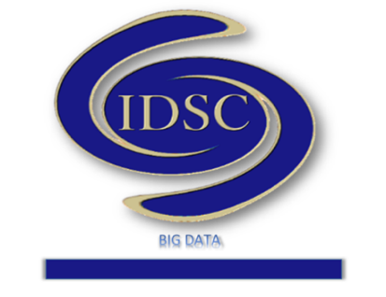

https://idscbigdata.com/
Interdisciplinary Data Sciences Consortium
Seminar Series

October 11, 2019, 2:00-3:00pm
Location: CMC141
Featuring Dr. Joel A. Rosenfeld
Department of Mathematics and Statistics
University of South Florida
Title: Interfacing Occupation Kernels with Dynamic Mode Decomposition for the Analysis of Continuous Time Systems.

Abstract: In this presentation, we will demonstrate how to incorporate trajectories as the fundamental unit of data in a reproducing kernel Hilbert space (RKHS) framework. The principle objects of study are occupation kernels, which interact with Liouville operators over RKHSs in much the same way that Liouville operators interact with occupation measures over the Banach space of continuous functions as investigated by Lasserre and his colleagues. The objective of this presentation is to demonstrate how these occupation kernels can be integrated into the kernel-based extended DMD framework initiated by Williams and Rowley to enable the direct DMD analysis of continuous time systems.
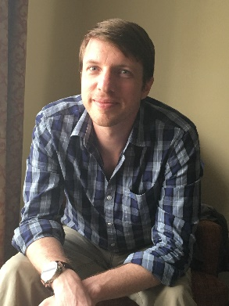
To learn more, visit: http://www.rosenfeldresearch.com/
Biography: Dr. Joel A. Rosenfeld received his Ph.D. from the University of Florida in Mathematics studying densely defined operators over reproducing kernel Hilbert spaces under Dr. Michael T. Jury. After graduating in 2013, Dr. Rosenfeld was a postdoctoral researcher in the Department of Mechanical and Aerospace Engineering at the University of Florida under the direction of Dr. Warren E. Dixon, and then was a postdoctoral researcher under Dr. Taylor T. Johnson at Vanderbilt University. His research is focused on data driven problems in control theory, such as system identification and dynamic mode decomposition. His methods intertwine his experience in operator theory and control theory to enable novel approaches using kernel methods.

IDSC Contact: Dr. K. Ramachandran
University of South Florida 4202 E Fowler Ave, CMC317 Tampa, FL 33620-5700
E‐mail: ram@usf.edu, Telephone: (813)‐974‐1270


