

The University of South Florida presents
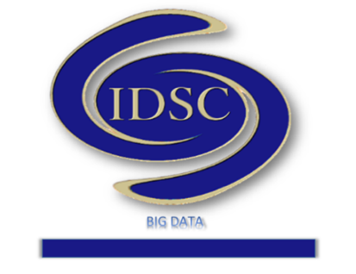

https://idscbigdata.com/
Interdisciplinary Data Sciences Consortium
Seminar Series

February 15, 2019, 2:00-3:00pm
Location: ISA 3050
Featuring Dr. Sagar S. Pandit
Physics Department
University of South Florida

Title: Molecular Mechanical Lipid Force Fields and ParOpt
Abstract: Lipids are primary components of call membranes. For last decade, focus of my lab has been to accurately simulate lipid bilayers and understand the physical principles behind this unique self-organization. To this end we have developed molecular mechanical force fields for various lipid components and validated these against experimental data. In this presentation I will describe the protocol and a software (ParOpt) developed by my group to derive the force field parameters from ab-initio simulations. We will discuss applications of ParOpt for simulations of lipid mixtures, coarse grained simulations of water, reactive simulations of Silica and water, and even modeling of small angle X-ray and neutron scattering data. We will discuss limitations and future development of ParOpt and potential role of machine learnt potentials.
To learn more, visit: http://physics.usf.edu/faculty/spandit/

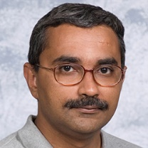
Biography: Dr. Pandit is an Associate Professor of Physics at the University of South Florida. His areas of interests include Computational Physics, Biophysics, Membrane Physics, Structure and assembly of lipid membranes, Statistical Mechanics and Molecular Simulations. Dr. Pandit received his PhD from University of Pune, India 1999 in Mathematical Physics. He has been working on lipid membrane assembly since 1995.

IDSC Contact: Dr. K. Ramachandran
University of South Florida 4202 E Fowler Ave, CMC317 Tampa, FL 33620-5700
E‐mail: ram@usf.edu, Telephone: (813)‐974‐1270


